**JENKINS ASSIGNMENT**

1. Install java , Jenkins , git , httpd .

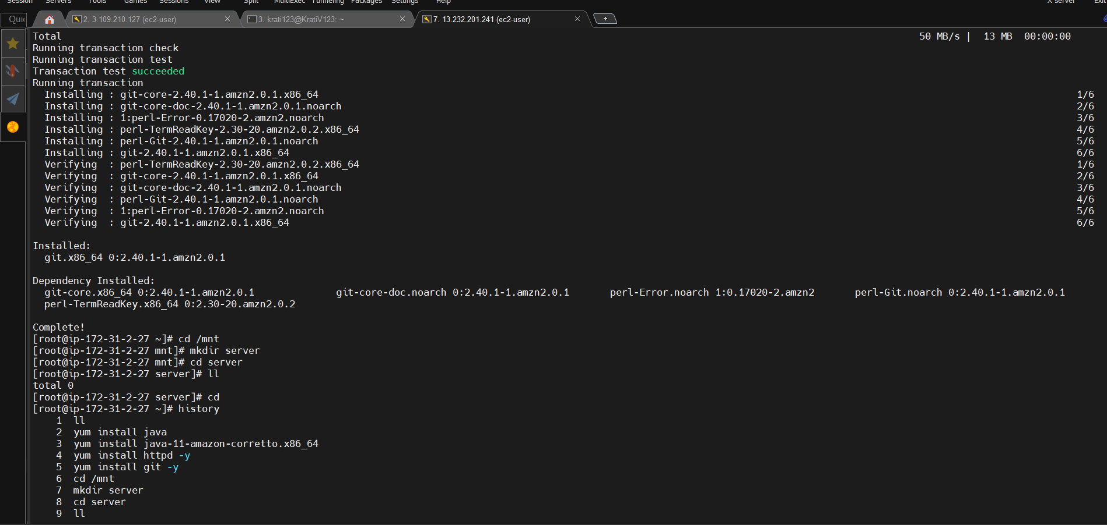

1. Create mnt folder new folder server download tomcat server upload html file in server

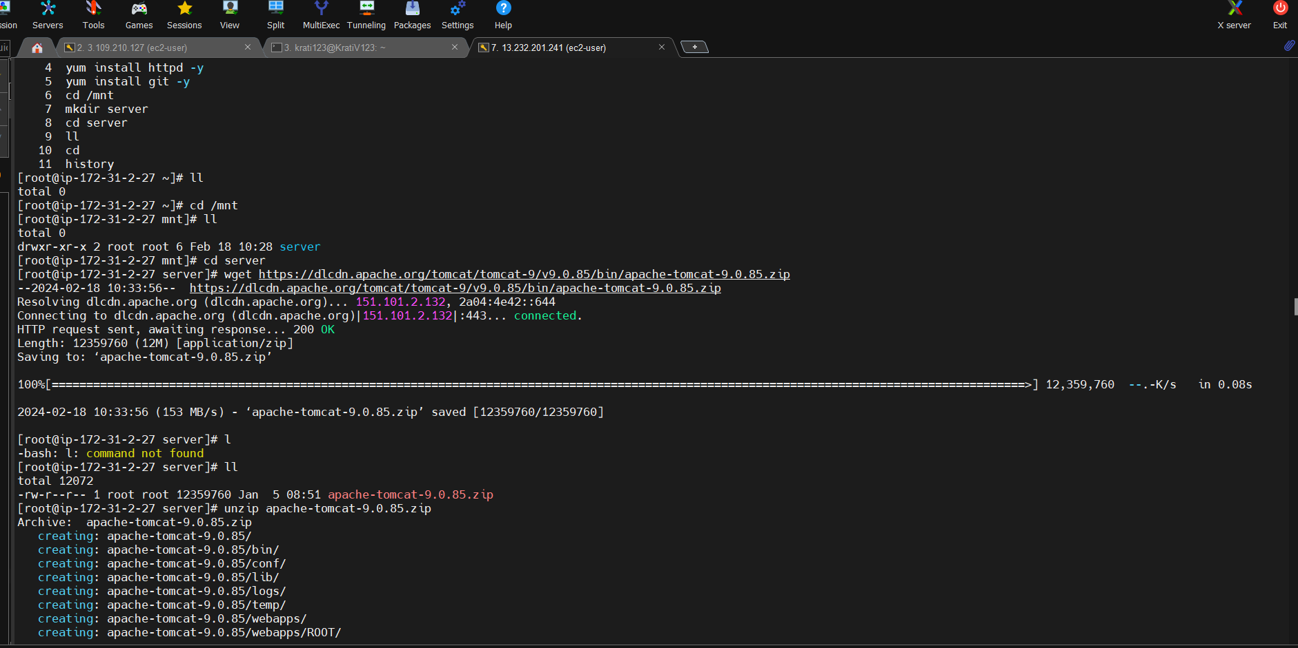

1. Create index.html file upload tomcat server

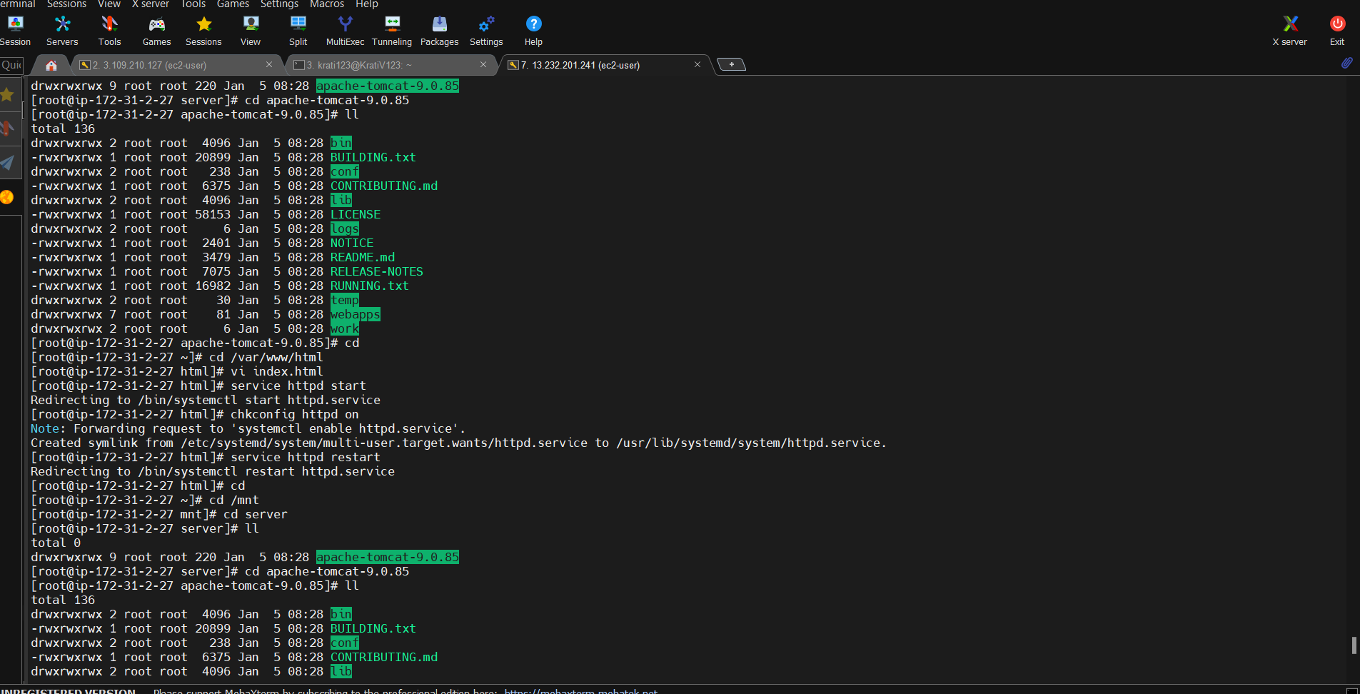

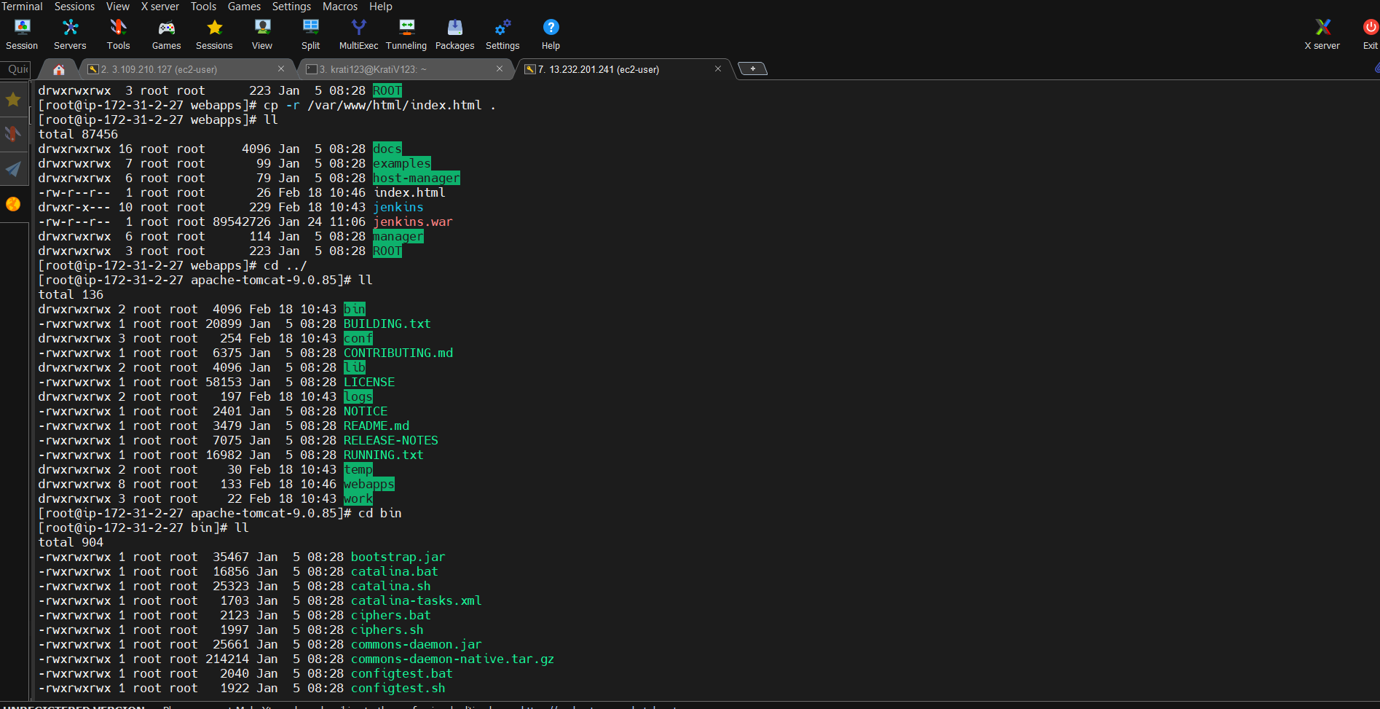

1. Upload file index.html in github repository

